PH eyes to expand halal food exports to MENA regions thru SIAL Middle East 2019

- The Philippines eyes to expand halal food exports in the Middle East and North Africa (MENA) region.
- DTI-CITEM joins one of the biggest food trade shows in the Middle East as the Philippines prepares for its upcoming country exhibit at the Dubai Expo 2020.

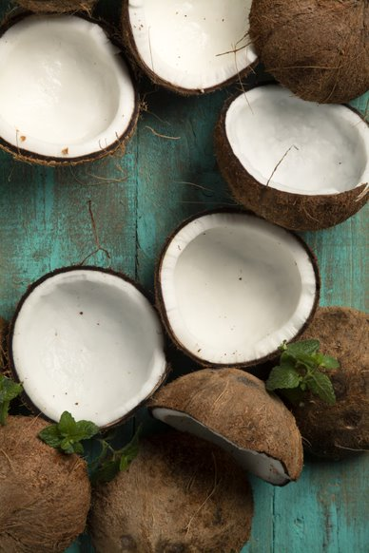
The Philippines is set to showcase its premier halal-certified food selections as it intensifies its export promotion activities in the Middle East and North African (MENA) region in the 10th edition of SIAL Middle East at the Abu Dhabi National Exhibition Centre, United Arab Emirates (UAE), Dubai on December 9-11, 2019.
The country’s delegation is set to gather halal manufacturers and exporters of fresh and processed fruits and vegetables, seafood products, ethnic and gourmet products, non-alcoholic beverages, confectionery, biscuits, and pastries, and many more under the FoodPhilippines banner.
“We are gathering a pool of Philippine food producers and manufacturers to bring a diverse selection of distinct, halal-certified Filipino products made from creative recipes and quality ingredients across our regions that bring out unforgettable flavors for the global market,” said Abdulgani Macatoman, Undersecretary for Trade Promotions Group (TPG) of the Department of Trade and Industry (DTI).
Coconut products, one of the Philippines’ top halal exports products in the Philippines, will be featured in SIAL Middle East 2019.
This year’s Philippine contingent will be led for the first time by DTI, through the Center for International Trade Expositions and Missions (CITEM), with a target to bring 10 companies and generate USD 1.5 million of export sales. The previous delegation was led by the Department of Agriculture (DA), through the Agribusiness and Marketing Assistance Service (DA-AMAS).

“With the growing number of halal food producers in the Philippines, this participation is part of DTI’s efforts to position our local exporters in the global halal food chain with our premium food and beverages,” said CITEM Executive Director Pauline-Suaco Juan.
“We are ramping up the country’s overseas promotion in the MENA region to expand the Philippines’ market reach and influence in the international halal network as the country further asserts itself in the region where there are also a lot of Filipino migrant workers,” she added.

According to Suaco-Juan, DTI’s export promotion activities to SIAL ME is also in preparation for the Philippine participation in the Expo 2020 Dubai in which a multi-level country pavilion will be built on a 3,100-square-meter plot of land in the event’s Sustainability District under the theme of “Bangkóta,” the ancient Tagalog word for coral reef, to let the world experience the Philippines—its people’s history, food, technology, art and design, nature, among others.
Suaco-Juan said buyers and visitors in SIAL will be able to taste and get a glimpse of what they can expect from the Philippine participation in the upcoming Expo 2020 Dubai.

Part of the SIAL Network, SIAL Middle East is backed by more than 50 years of experience, industry know-how and a broad international network of 8 leading B2B events. SIAL Middle East is jointly organized by Abu Dhabi National Exhibitions Company (ADNEC) and Comexposium.
In 2018, SIAL Middle East attracted 20,529 unique trade visitors from the food, beverage and hospitality industry, wherein more than 90 countries were represented by the visitors at the event. Overall, USD 1.93 billion worth of deals were signed between exhibitors and visitors.
Rising demand for PH food in the Middle East market

“The demand for Philippine bananas (fresh), processed food and beverages and pineapple products continues to surge. Last year, these food segments were included in the top five exports to the UAE and have garnered USD 56.3M, USD 52.6M, and USD 14.1M, respectively, in terms of total export value,” said Suaco-Juan.

In 2017, the UAE ranked as the Philippines’ 17th trading partner, 17th export market and 18th import supplier. Philippine exports to the UAE grew by 89.22 percent from USD 309.58 M in 2016 to USD 585.79 M in 2017. Likewise, Philippine imports from the UAE increased by 25.07 percent from USD 583.53 M in 2016 to USD 729.82 M in 2017. In the same year, the UAE ranked as the 23rd source of approved investments.

“A contributor to the Philippines’ stronger trade relations to UAE are the Filipinos living in that country, which is said to have been around 770,000—making Filipinos the 3rd largest expat community next to Pakistanis and Indians,” Suaco-Juan noted.

As of 2018, the global halal market is valued at USD 2.6 trillion with the bulk or 62 percent of the halal market comprised of food and beverages followed by pharmaceuticals, 22 percent; cosmetics and personal care, 10 percent; and nutraceutical, 6 percent.

According to David Smith of Global Futures and Foresights Study, the halal industry is projected to be a USD 10-trillion industry by 2030, making it one of the fastest-growing consumer segments in the world.

The Philippines joined last year in the International Halal Accreditation Forum (IHAF), an independent, non-government network of accreditation entities mandated to enforce halal standards in their countries and territories. Mandated to protect the growing number of halal consumers and to facilitate international trade, IHAF establishes a solid ground for the global industry of halal food and non-food products.

The DTI eyes halal to become a major industry in the Philippines due to several key factors such as the increasing demand for halal products even in non-Muslim markets; increased awareness of the availability, quality and integrity of halal products; increase in number of certifiers to ensure quality, integrity of halal products in the market; emerging new categories of halal-certified products and services; globalization and integration of markets; and growth in e-commerce and online platforms.

This participation under FoodPhilippines is led by DTI-CITEM in partnership with the PTIC office in Dubai, Export Marketing Bureau (EMB), the Philippine Exporters Confederation (PHILEXPORT), Inc. and Foreign Trade Services Corps (FTSC) as part of the government’s unified effort to promote the Philippines as a source of quality food products in the global market.
DTI-CITEM is committed to developing, nurturing and promoting globally competitive small and medium enterprises (SMEs), exporters, designers and manufacturers by implementing an integrated approach to export marketing in partnership with other government and private entities.
###
Ref. Ryanorlie Abeledo
Tel: 831-2201 local 253
Email: rabeledo@citem.com.ph
Twitter: @CITEMPh
Facebook: @DTI.CITEM

