Press Release: Business/Lifestyle

Philippine fashion brands to tell cause-oriented stories at Project Womens Las Vegas 2019
- FashionPhilippines joins the most comprehensive US fashion market this year under a new show

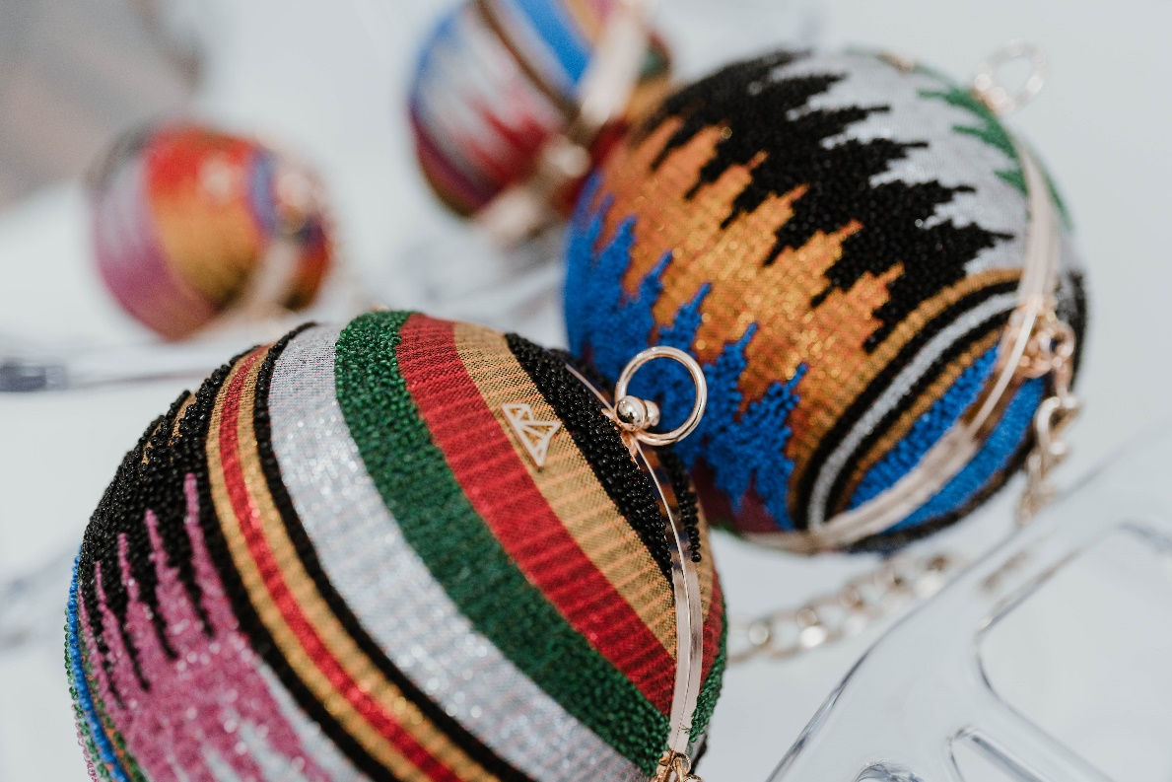
This colorful Lucy Mini clutch from Vesti is one of the many high-quality accessories that buyers can look forward to at Project Womens this year.

Eight Filipino fashion brands will be telling stories of their colorful and purpose-oriented brands as the country participates in this year’s Project Womens Las Vegas, which will be held on August 12 to 14, 2019 at the Las Vegas Convention Center in Nevada, USA.

The Philippine participation at Project Womens is organized by the Department of Trade and Industry’s Center for International Trade Expositions and Missions (DTI-CITEM). Carrying the FashionPhilippines campaign, CITEM aims to show the American audience the story of Filipino innovation and skillfulness that comes with its quality lineup of fashion companies.

Project Womens is one of the shows taking place within the Men’s Apparel Guild in California (MAGIC) trade fair, which takes place in February and August each year. MAGIC is the most comprehensive fashion marketplace in the United States and showcases the latest in men’s, women’s and children’s fashion, accessories, footwear and fashion resources. Previously held in several venues in Las Vegas, MAGIC has now gathered all of their 12 shows in one venue, making
it easier for buyers from the United States and North America to see the latest or future trends and to source new products.

The Project Womens collective houses the best emerging and established brands, many of which are noteworthy and cause-oriented. The eight Filipino fashion brands joining this year are all committed to making contemporary footwear and accessories while incorporating sustainable, earth-friendly materials and ethical business practices. The focus of FashionPhilippines at Project Womens this year will be the innovative minds and skillful hands of the country’s design talents, who use traditional and modern manufacturing techniques in manipulating various raw materials into veritable works of art.

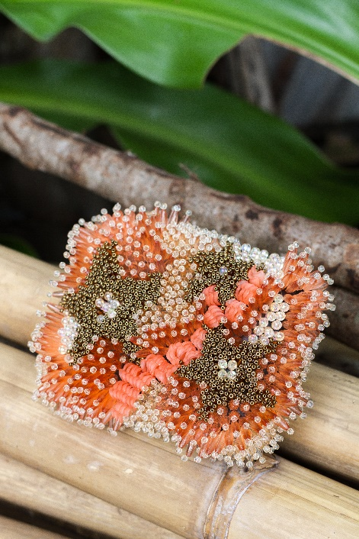
“We are eager to join the revitalized MAGIC and Project Womens this year,” says CITEM Executive Director Paulina Suaco-Juan. “We feel that the Filipino brands participating this year are a better fit at Project Womens, and we hope that buyers will get to appreciate the dedication and workmanship that went into making these products, as well as their stories of community empowerment.”

The Philippine companies joining this year are Agsam Fashion Fern Accessories, Beatriz, Calli, Virtucio, Ken Samudio, Lara, Maco Custodio and Vesti. Of these eight brands, five use locally- and sustainably-sourced natural materials. Three brands—Virtucio, Maco Custodio and Ken Samudio—work with upcycled plastic and foil packs to make finely-crafted footwear and accessories. All of them work with local indigenous communities or with organizations that empower disadvantaged people through livelihood projects.

“Beyond the artisanship seen in the quality of our products, it is the story of how they were made that makes them stand out,” Suaco-Juan adds. “It’s how business owners, designers, artisans and workers came together to make beautiful, eco-conscious and fashionable products that are distinctly Filipino.”
Ken Samudio’s masterpieces use beads made from upcycled plastic

The participation of these companies in Project Womens is a precursor to their participation in the 70th edition of Manila FAME, which will take place on October 17 to 19, 2019 at the World Trade Center Metro Manila. Know more about the brands by visiting the Manila FAME and Project Womens’ official websites.

###
Ref. Ryanorlie Abeledo
Tel: 831-2201 local 253
Email: rabeledo@citem.com.ph
Twitter: @CITEMPh
Facebook: @DTI.CITEM

