Press Release: Lifestyle

Filipino Brands Filip + Inna and Merriam Batara Debut in Premiere Classe Tuileries

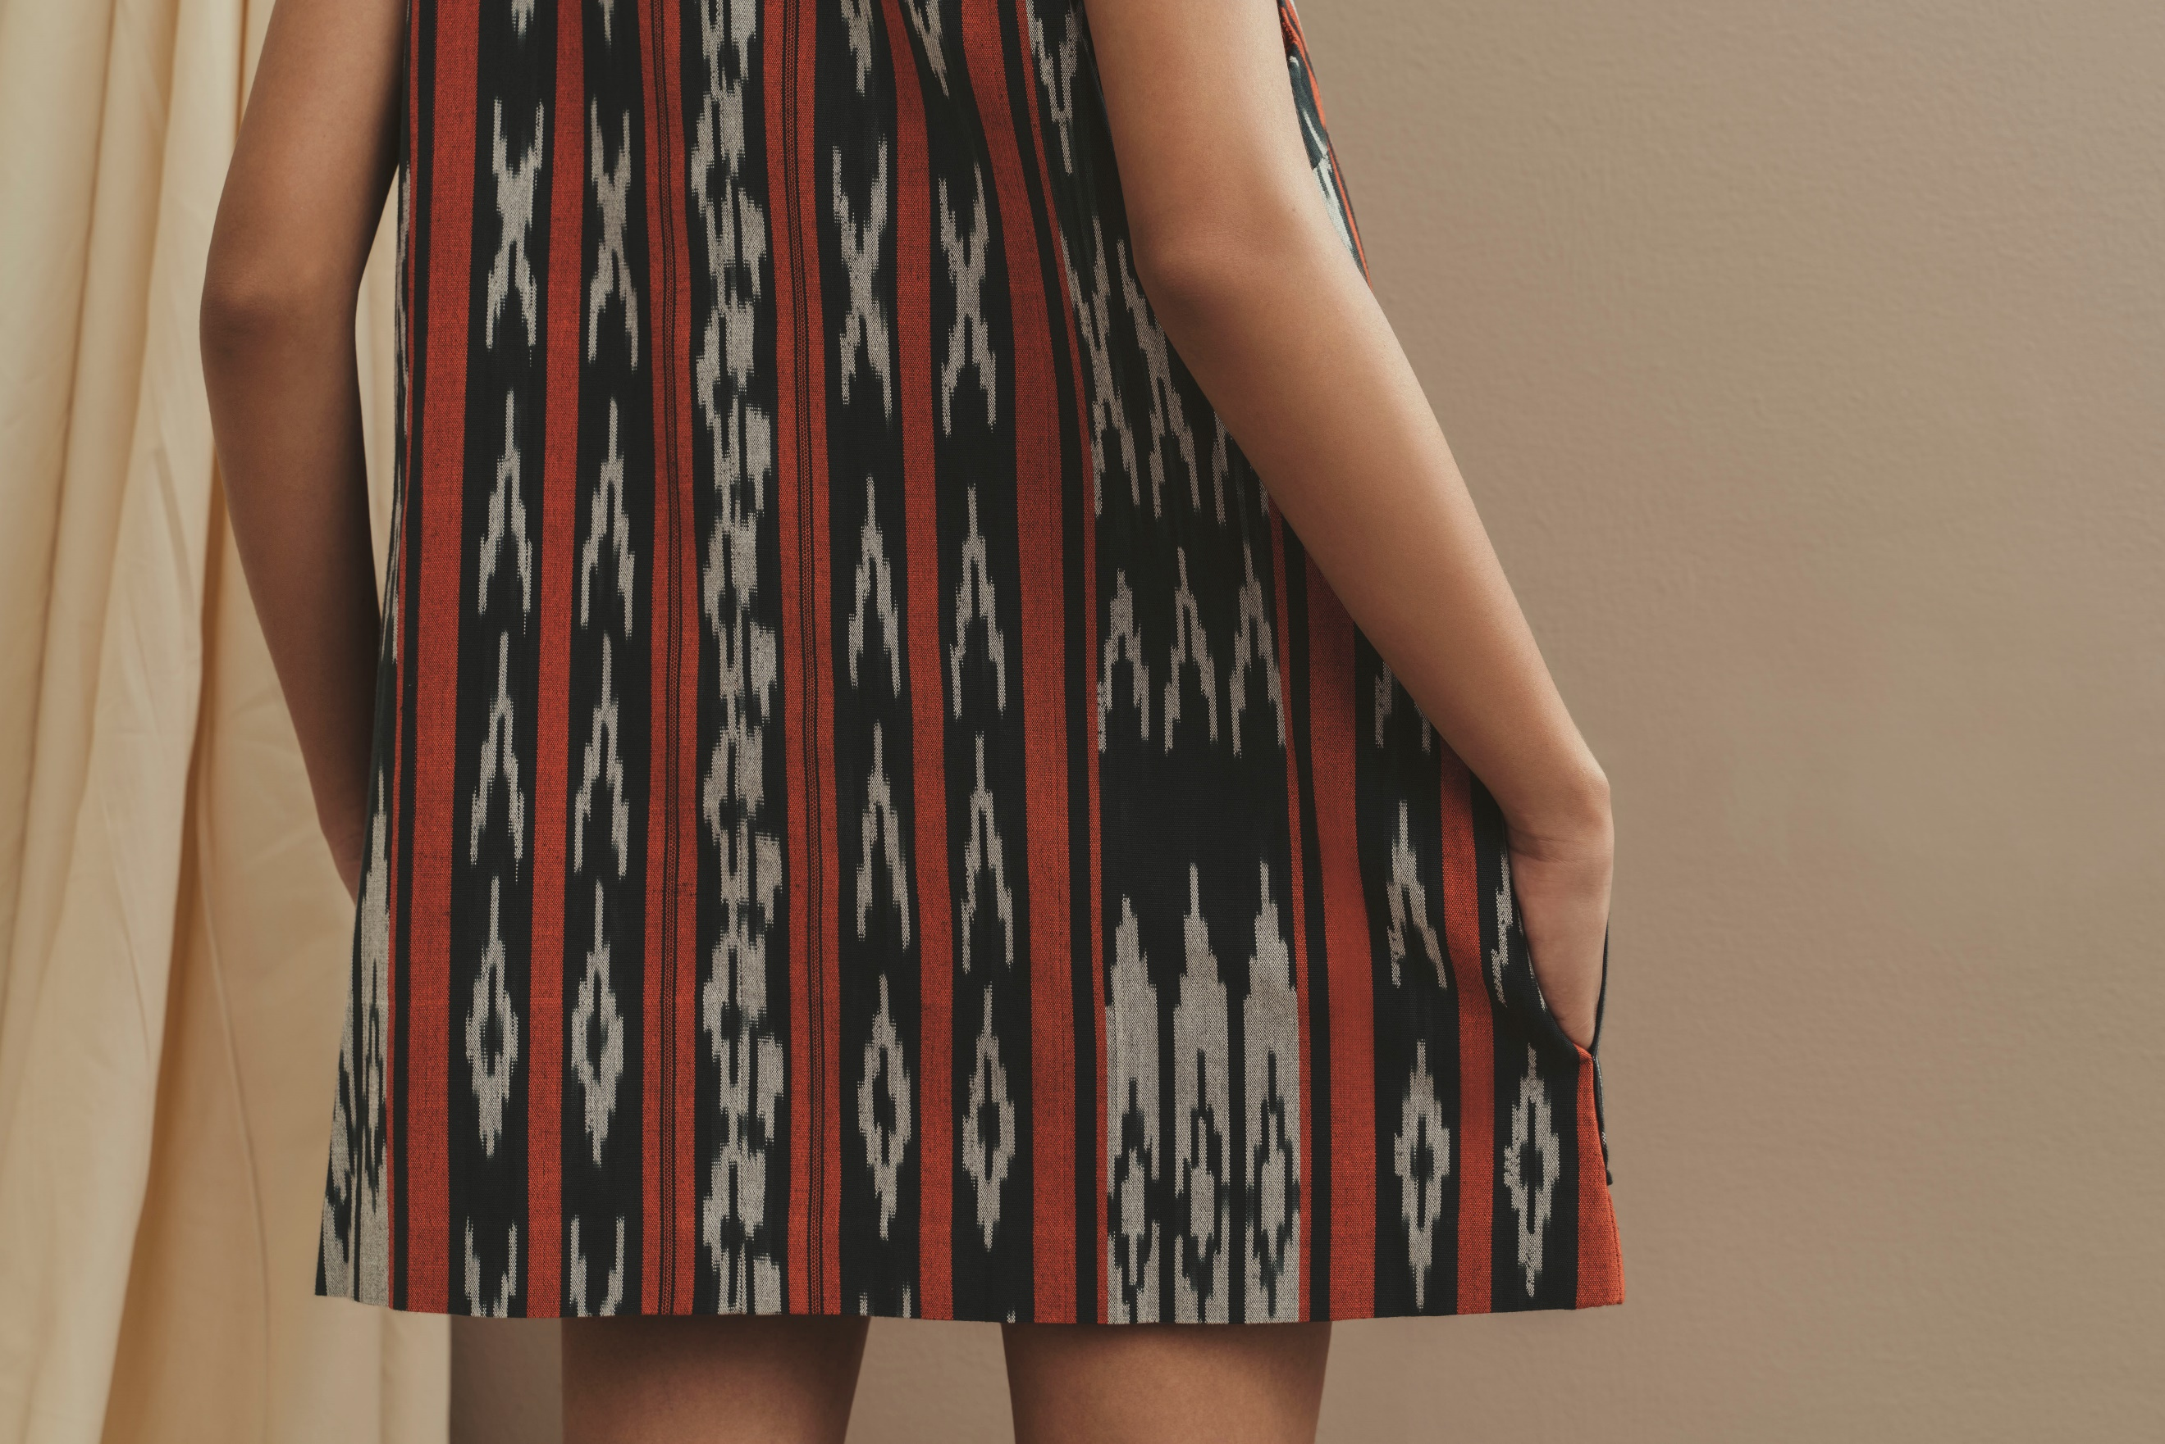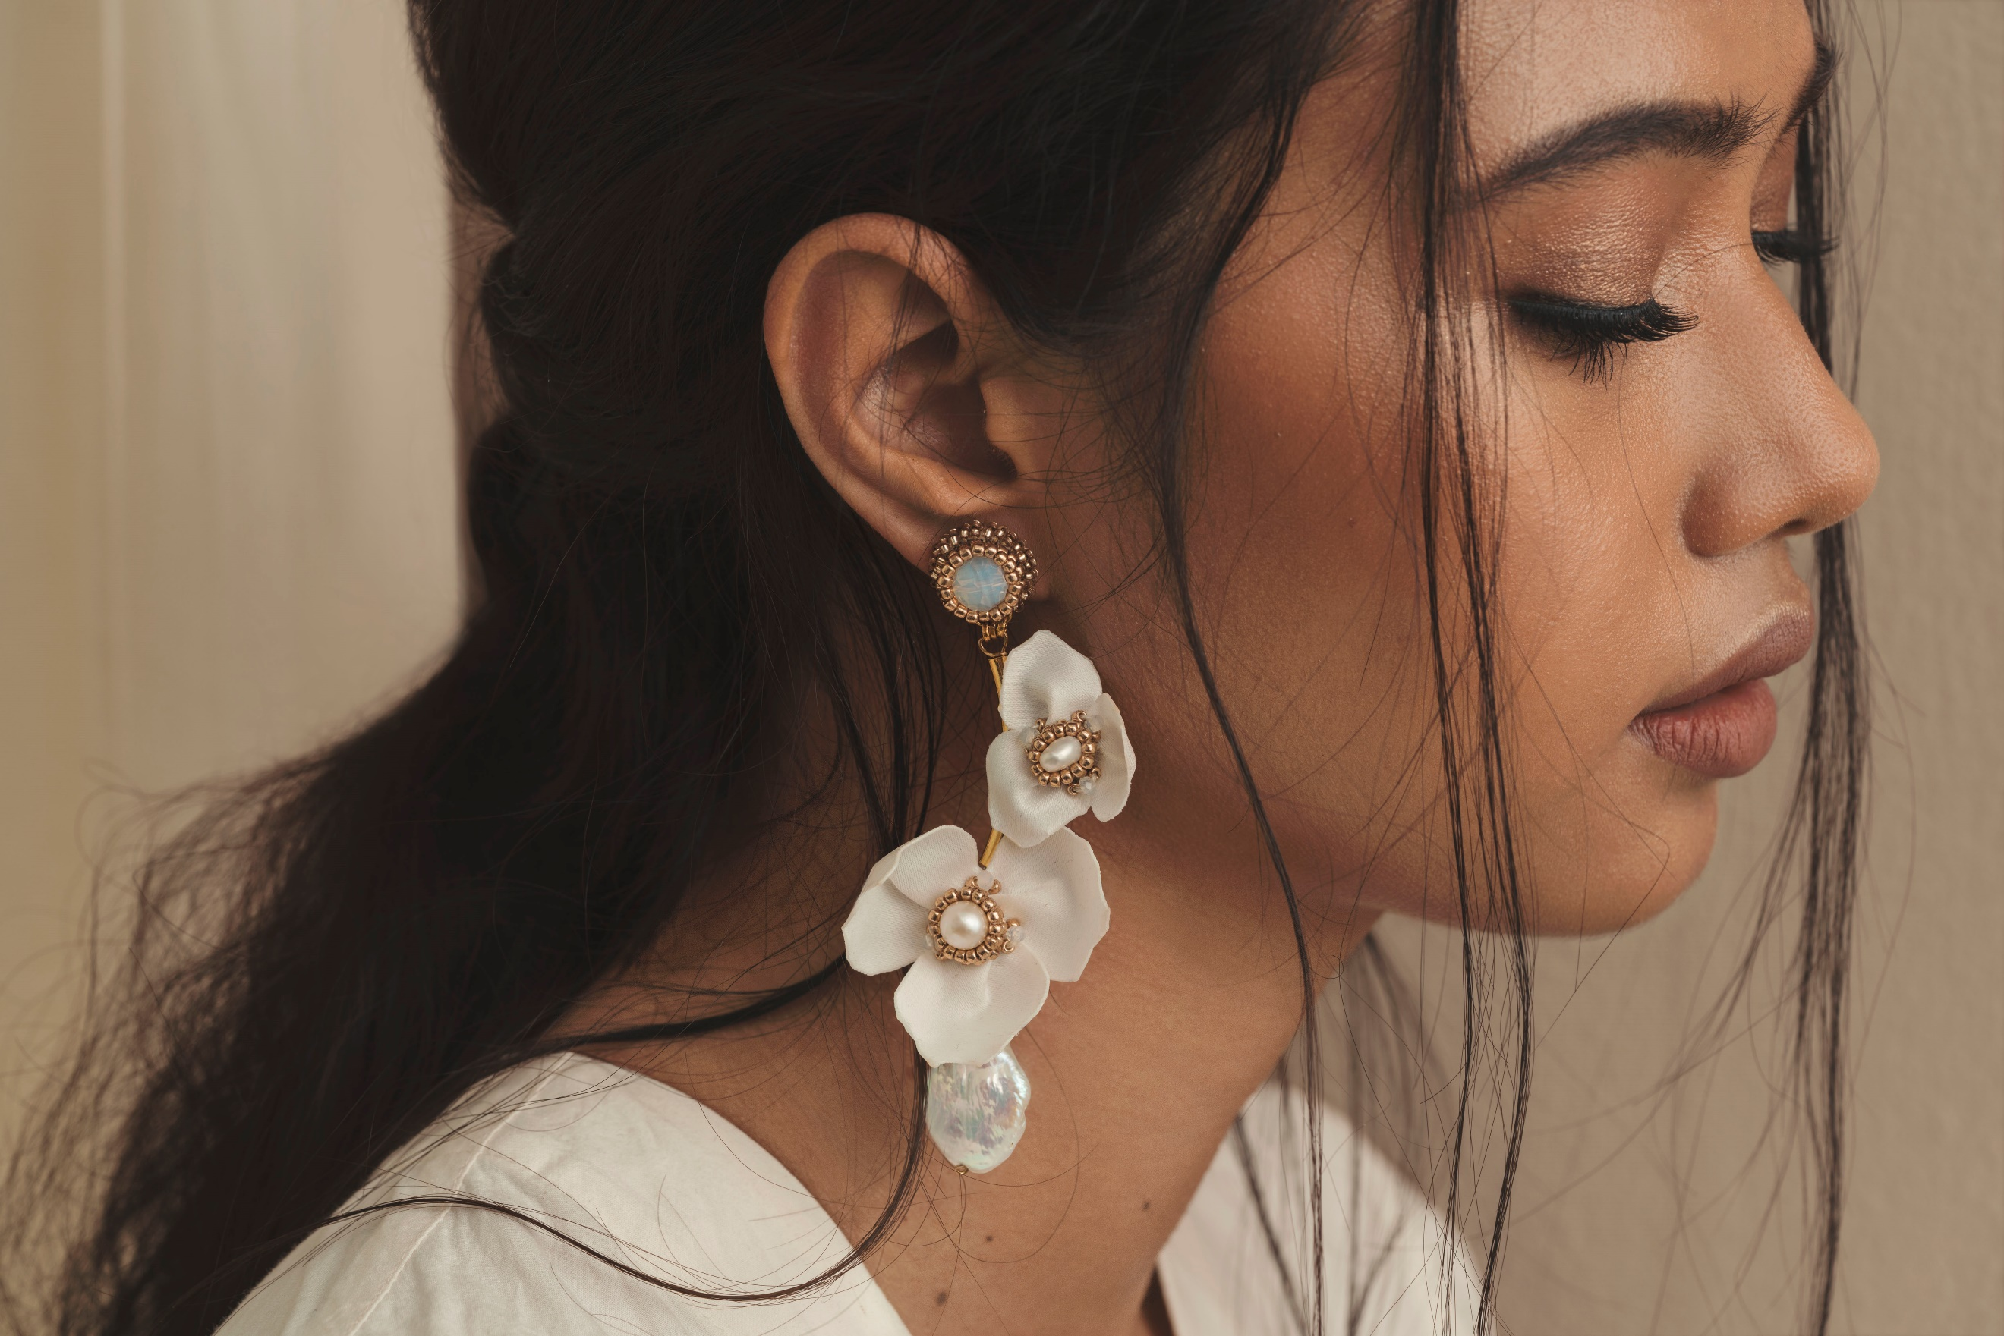
Select pieces from Premiere Classe newcomers Filip + Inna (left) and Merriam Batara (right)

MANILA, Philippines; September 2019 – Two local fashion brands, Filip + Inna and Merriam Batara, are set to impress the global market with their uniquely handmade designs at the Premiere Classe trade show which will be held at the iconic Jardin des Tuileries in Paris, France, on September 27 to 30.

This year, there are a total of seven brands—Aranaz, Beatriz, Filip + Inna, Joanique, Mele + Marie, Merriam Batara, and Zacarias 1925—bringing Filipino designs to Premiere Classe. However, both Filip + Inna and Merriam Batara are joining the Tuileries edition for the first time.

The prestigious Premiere Classe fashion and accessories trade fair was previously held twice in September for almost 30 years. Both in Paris, the Porte de Versailles edition, now discontinued, happened in the earlier days of the month, while the Tuileries edition took place later in September during Paris Fashion Week. Because of the latter’s strategic timing and location, countless buyers, magazine editors and online publishers easily visited the event to discover and gain inspiration from new, innovative and high-end fashion and accessory brands from all over the world.

Joining this elite list of exhibitors is jewelry designer Merriam Batara, founder and head designer of her eponymous label, who will put the spotlight on Filipino artistry through her hand-beaded and embroidered accessories. “Showcasing Filipino creativity and craftsmanship in Paris through our handcrafted collection—amongst the best of the best in the world to the most prestigious markets—is a dream for us, and Premiere Classe is the stage to make that all happen,” shared Batara.

Though her boho-luxe tasseled earrings are already a signature of the brand, Batara’s Spring/Summer 2020 collection takes a decidedly fresh turn. Inspired by the flora and fauna of the Philippines, the earrings, cuffs, and other jewelry in this collection are made with a mix of freshwater pearls, gold-dipped shells and metal hardware, gemstones, woven indigenous fabrics, chains and glass beads that all come together through beading, hand-embroidery and wirework.

Filip + Inna’s Lenora Cabili, on the other hand, lives by her mission of preserving and promoting the age-old techniques and garments of the Philippines’ indigenous groups through her clothing line. Her latest collection seamlessly combines indigenous weaves, patterns and traditional garb reimagined through contemporary silhouettes like chic separates and breezy tunics. Embroidery and beadwork techniques from the T’boli, Tagakaolo and B’laan ethnic groups based in Mindanao, where Cabili grew up, are also celebrated through key pieces in the collection.

For Cabili, presenting abroad is more than just the sale of her brand’s products. “Selling our collection to the international market has been a most rewarding experience,” she shared. “The opportunity to show the world a side of the Philippines that not a lot of people know about is an honor and responsibility I am most grateful for. We are defining and creating a visual of the Filipino culture through the garments produced by the indigenous groups.”

Participating in international shows entails a lot for designers with smaller enterprises whose aim is not only to sell their goods but promote the well of artistry the Philippines has to offer as well.

Continued efforts by the Center for International Trade Expositions and Missions (CITEM), in collaboration with these fashion labels, help to bridge the gap between local brands and the international market.

Support local and visit the booths of Filip + Inna and Merriam Batara at the Premiere Classe Tuileries for a dose of meticulously handmade Filipino fashion and accessories.

For more information on the event, as well as other projects, visit citem.gov.ph.

###

Ref. Ryanorlie Abeledo
Tel: 831-2201 local 253
Email: rabeledo@citem.com.ph
Twitter: @CITEMPh
Facebook: @DTI.CITEM

