Press Release: Lifestyle

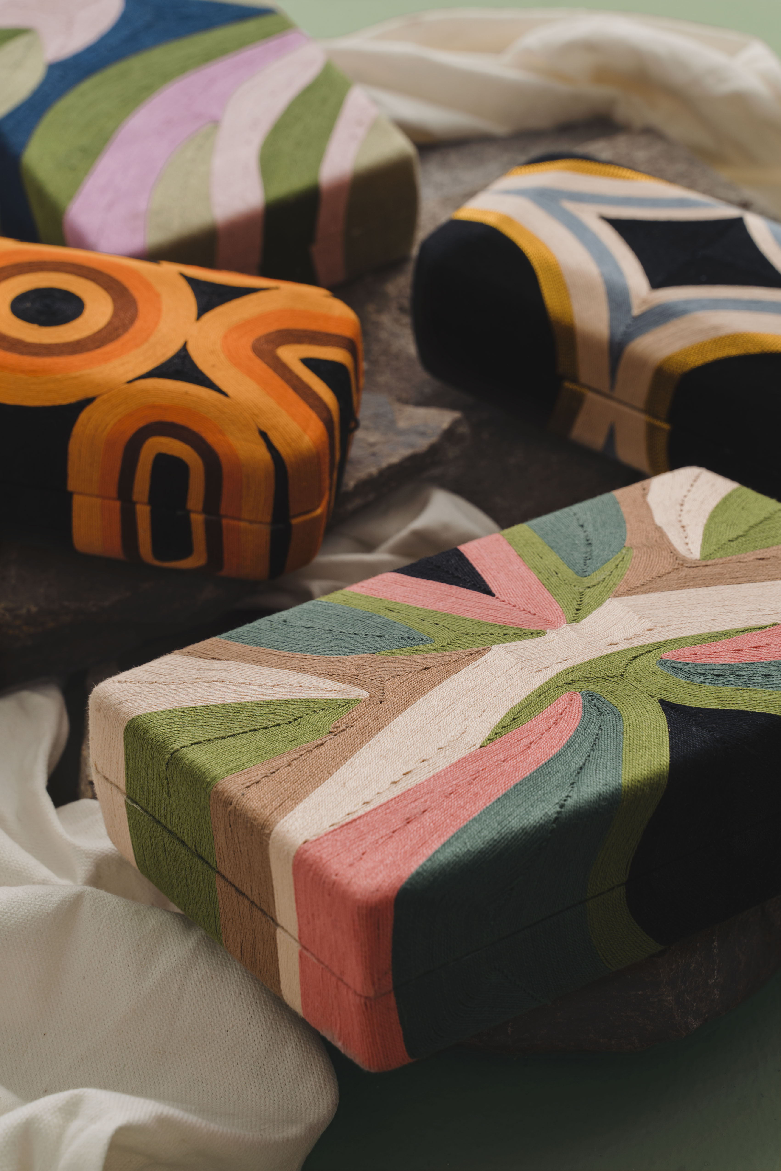
These Fashion Brands Are Returning to the Premiere Classe Trade Show in Paris
Beatriz returns to Premiere Classe Paris with their signature vibrant patterns and an upcoming collection with Paris-based designer Lou Leygnac.

MANILA, Philippines; September 2019 – From September 27 to 30, the Premiere Classe fashion accessories trade show will be held at the iconic Jardin des Tuileries in Paris. Presenting the unique craftsmanship of the Philippines in this prestigious event are seven local fashion brands—Aranaz, Beatriz, Filip+Inna, Joanique, Mele + Marie, Merriam Batara and Zacarias 1925—that specialize in designing and manufacturing handbags, jewelry, and even apparel.

Of these seven labels, Aranaz, Beatriz, Joanique, Mele + Marie, Merriam Batara and Zacarias 1925 have previously joined Premiere Classe. Considered as the unmissable international platform for fashion accessory designers to present their products to a global market, particularly that of Europe, the six fashion brands are all eager and excited to represent the Philippines once again.

“We are looking forward to representing our country and meeting the best stores in the world at Premiere Classe,” shares Carissa Cruz-Evangelista, founder and chief designer of accessories line Beatriz, “Showing our products side by side with the best brands in the world gives us great pride! It is truly a privilege we appreciate and are grateful for.” For this edition of Premiere Classe, Beatriz will be bringing their signature vibrant thread patterned-clutches, bucket bags, and accessories, as well as their collection in collaboration with Paris-based designer Lou Leygnac.

Rosemarie and Melecio Oamil of Mele + Marie echo this same sentiment. For the couple, returning to Premiere Classe means continually showcasing what Filipinos can offer the world. “We are proud to be a Filipino brand and we are always excited to promote our country,” shares Rosemarie. The brand’s handmade abalone shell minaudières and hand-welded metal cage purses all feature Filipino design and craftsmanship at par with any imported label.

For Aranaz’s lead designer and creative director Amina Aranaz-Alunan, meanwhile, Premiere Classe is a source of inspiration, “We look forward to being surrounded by so much talent under one roof. It is always an inspiring and eye-opening experience for us.” While the tropical-luxe label is popular locally, Aranaz-Alunan also sees the participation in international trade fairs as a learning experience, “It is an opportunity for us to be able to exchange ideas, receive feedback, and gain perspective from creative minds from all over the world.”

The brand will be launching their Spring/Summer 2020 Fresh Catch collection reflecting the textures, patterns and icons of a fisherman’s life from above and under the sea. Bringing these to life are mother of pearl paillettes that mimic fish scales, wooden beads reminiscent of floating buoys and macrame weaves that represent ropes.

Joanique’s Malou Romero has learned from her years of participating in Premiere Classe that buyers love products with a good story. Fortunately, Romero’s designs always feature stories, traditions, and aspects of the Philippines’ rich and diverse culture.

Joanique’s latest collection is an ode to the indigenous painted men from Cebu during the Spanish colonial era. “These tattoo-covered warriors believed the patterns on their skin possessed spiritual powers and magical qualities,” explains Romero, “Obtaining these tattoos involved an agonizing process of cutting and prickling their battle-hardened skin, parallel in a way to how our Pintados bags are hand-carved and nicked from wood.”

Jewelry designer Merriam Batara returns to Paris for Premiere Classe for the third time, and like the previous years she has joined, her pieces not only elevate the craft of hand-beading and embroidery, but also feature the work of the disadvantaged communities she helps. These include out of school youth, as well as young, unemployed mothers in Batara’s hometown of Baliuag, Bulacan. These trained hands have worked on the designer’s latest collection inspired by the flora and fauna of the Philippines. “I took inspiration from our tropical rainforests down to our rich marine life,” says Batara, “The pieces are made with a mix freshwater pearls, gold-dipped shells and metal hardware, gemstones, woven indigenous fabrics, chains and glass beads. They all come together through beading, hand-embroidery and wirework.”

Meanwhile, seasoned participant Rita Nazareno, creative director of her label Zacarias 1925 shares what she’s excited about this time around. “We are looking forward to showing our collection at Premiere Classe for the 6th time, as well as meeting our current clients and building relationships with new ones.” While Zacarias 1925’s collections will always feature the intricate and progressive weaves handmade by the skilled artisans in their workshop, new elements like ombré patterns, tropical-military references, and an ode to the Queen of Funk, Betty Davis, via a crown-shaped purse will surely attract buyers and editors alike.

Discover more of the designs these brands are bringing to the global stage and how they’re championing Philippine craftsmanship at the Premiere Classe trade show in Paris.

For more information on the event, as well as other projects, visit citem.gov.ph.

###

Ref. Ryanorlie Abeledo
Tel: 831-2201 local 253
Email: rabeledo@citem.com.ph
Twitter: @CITEMPh
Facebook: @DTI.CITEM

