Press Release: Business

PH designers to highlight natural and eco-sustainable materials at INDEX Dubai 2019
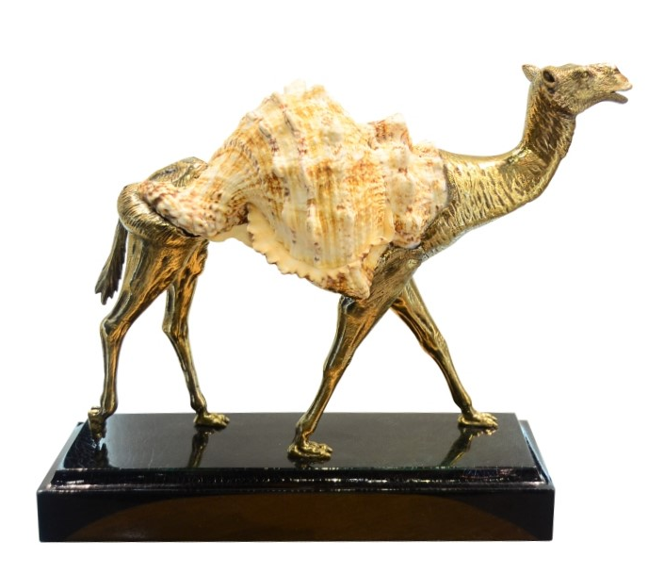
Frog shell and brass camel by Arden Classics

Lifestyle products crafted from natural and eco-sustainable materials will be the focus of this year’s Philippine participation at INDEX Dubai, the biggest design event in the Middle East and North African (MENA) region, which opens this 17-19 September 2019 at the Dubai World Trade Centre, United Arab Emirates (UAE).

Organized by the Center for International Trade Expositions and Missions (CITEM), the export promotion arm of the Department of Trade and Industry (DTI), in partnership with the Export Marketing Bureau (EMB) and the Philippine Trade and Investment Center in Dubai (PTIC-Dubai), the participation will feature seven companies from different lifestyle sectors namely, furniture & furnishings, home décor and fashion accessories.

“This participation will bring to the forefront the resourcefulness and ingenuity of our skilled Filipino craftsmen and designers,” said DTI-CITEM Executive Director Pauline Suaco-Juan. “Through their intricate and innovative pieces, these exhibitors will help elevate Philippine design in both the Middle Eastern and the global markets.”

The seven companies will feature their latest creations that promote world-class craftsmanship made with locally sourced, eco-sustainable or repurposed materials like old fabrics, driftwood pieces, natural seashells from non-endangered species and other reusable objects that are typically considered as “waste,” to emphasize that responsible sourcing is an integral aspect of the Philippine design industry.
Repurpose, Reuse, Recycle

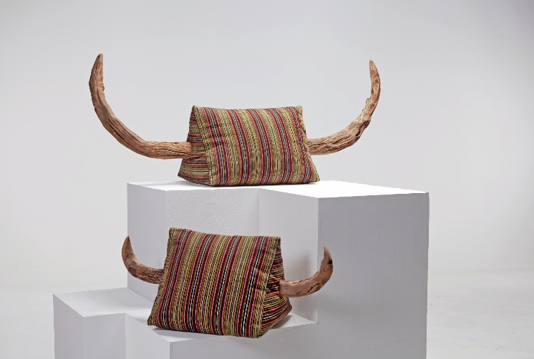
Exhibiting under the Philippine participation are companies that include James Doran-Webb and Furniture Doctor. Both use raw and re-engineered drift wood to create original and functional furniture pieces.

Another furniture exhibitor, Coast Pacific, perfectly balances the use of natural and synthetic materials in developing new weaving patterns and enhancing traditional techniques for their product line. Joining these furniture companies in Dubai are two fashion accessory brands: traditional jeweler, Kit Silver; and minaudière maker, Mele + Marie.
Horns by James Doran-Webb

Rounding off the list are two home décor and accessory companies: Arden Classic with their blend of natural seashells and metalworks that depict the magnificence of nature; and Bon-Ace with their home accessories made with all-natural materials designed with Filipino and Italian influences.

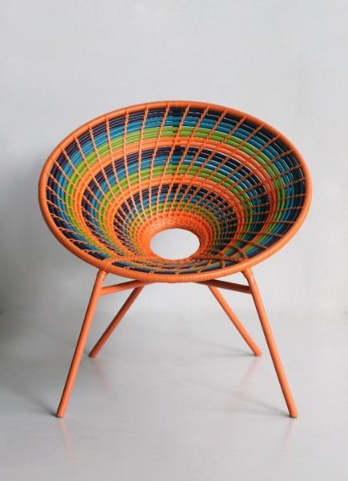
DTI-CITEM targets bigger sales in MENA region

After doubling its sales target in last year’s edition with US$2.77M, the Philippines is now eyeing to generate US$2.9M in export sales for this year’s show.

CITEM is partnering with the Export Marketing Bureau to achieve optimum results for this year’s participation, with DTI-EMB organizing business-matching activities during the show proper.

Get up close and personal with the latest eco-sustainable designs from these exhibitors at Stand #4D151 in Hall 3 of the Dubai World Trade Centre, United Arab Emirates, this 17-19 September 2019.
Sansa Chair by Coast Pacific

###

Ref: Ryanorlie B. Abeledo
Tel: (+632) 831 2201 local 253
Email: rabeledo@citem.com.ph
Website: www.citem.gov.ph
Twitter: @CITEMPh
Facebook: @DTI.CITEM

