Press Release: Business

Philippine design and craftsmanship set to captivate the Middle East at INDEX Dubai 2019
- DTI-CITEM brings original Philippine design and craftsmanship to the biggest design event in the MENA region.

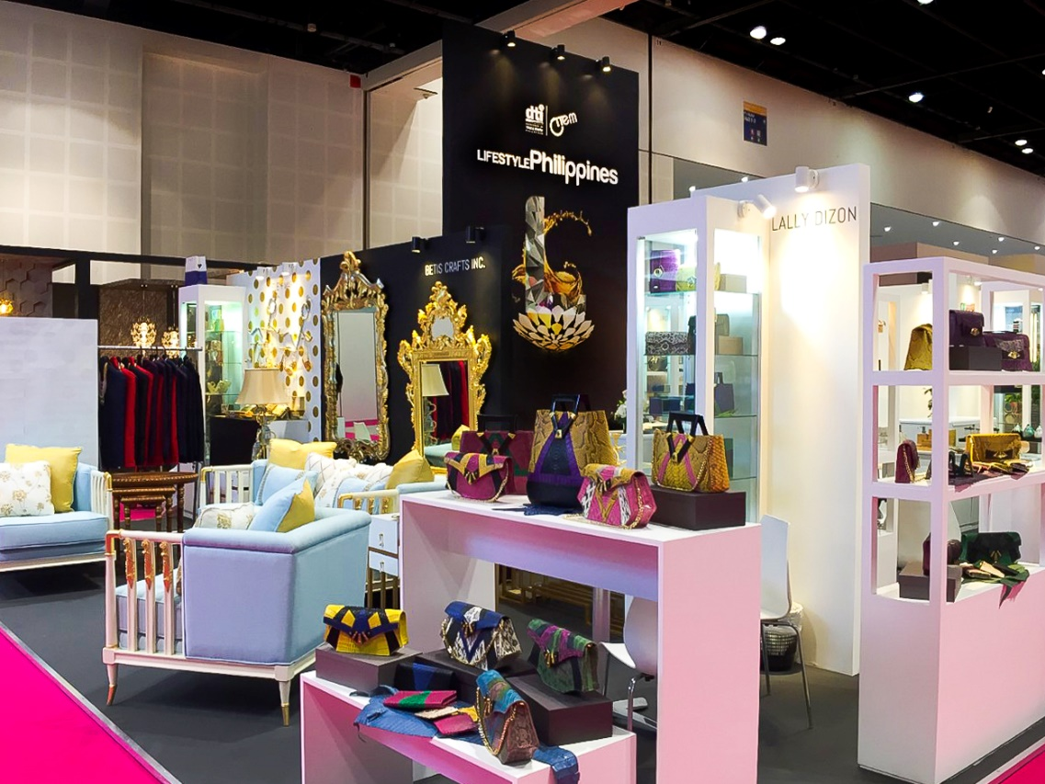
LifestylePHILIPPINES at INDEX Dubai 2018
Before launching the 70th Edition of Manila FAME this October, the Department of Trade and Industry (DTI), through the Center for International Trade Expositions and Missions (CITEM), will showcase some of the most promising brands in the home accessories and furniture industry at the upcoming INDEX Dubai 2019 this September 17-19 at the Dubai World Trade Centre, United Arab Emirates.

INDEX Dubai is reputed as the largest gathering for the design community in the Middle East and North African (MENA) region and is part of the Middle East Design and Hospitality Week (MEDHW) 2019. The MEDHW is one of the largest celebrations of all things design and hospitality. Six other design shows are set to take place alongside INDEX Dubai, bringing with them around 1,000 exhibitors and an expected turn out of more than 50,000 visitors from all over the world. These visitors include architects, developers, interior designers, procurement professionals and retailers.

The Philippine participation in last year’s INDEX Dubai was a successful return to the show after nine years. CITEM brought a delegation of 10 companies, which generated US$2.766M in export sales, double the initial sales target. In addition, the almost 1,000 buyer inquiries received during the show were more than four times the initial target, indicating a positive turnout and reception of Philippine furniture and accessories design in the Middle East.

According to a study by Ken Research on the UAE’s furniture market outlook through 2022, the highly-competitive furniture industry in the UAE is forecasted to expand in the near future leading up to the launch of the year-long World Expo 2020 to be held in Dubai. One of the largest events in the world, EXPO 2020 will significantly grow the demand for furniture in Dubai as the event is expected to bring a huge influx of tourists that will create a surge in the demand for tourism products and services in the city. Local and international furniture manufacturers will have their hands full as they try to supply the demand generated by the hotel inventory of 140,000 rooms and apartments required to meet the number of tourists and expatriates expected to arrive.

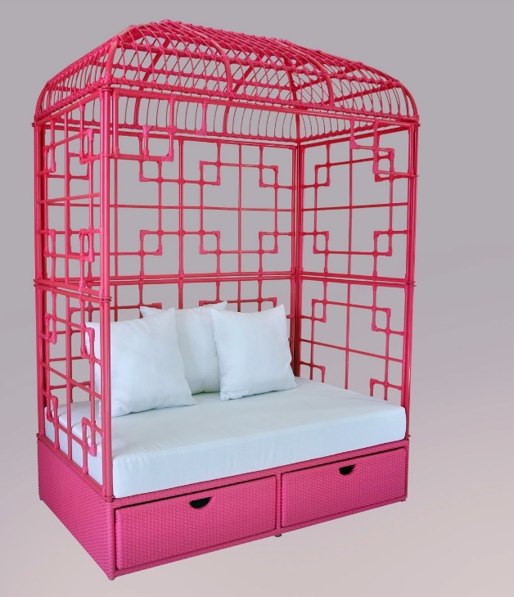
“This is the perfect opportunity for our furniture designers and craftsmen to capture the attention of the Middle Eastern market and show the world the level of creativity and sophistication that the Philippines has to offer,” said DTI-CITEM Executive Director Pauline Suaco-Juan. “This year’s Philippine participation will focus on innovative and sustainable furniture and home accessories which involve design materials and techniques that showcase the distinct talents and skills of Filipino designers,” she added.

Six exhibitors from the country’s furniture and accessories sectors make up the delegation this year. Most of these companies are first-time exhibitors including Furniture Doctor, Cebu Homecraft, Coast Pacific and Kit Silver. Joining them are returning exhibitors Arden Classic and Mele + Marie.
Birdcage Daybed by Coast Pacific

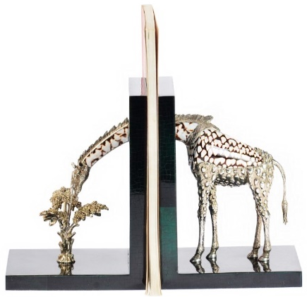
These exhibitors will feature their newest and most innovative designs that highlight how they translate local materials and crafting techniques to create functional and eco-sustainable products that are proudly and truly Filipino.

See the latest from these exhibitors and more at the Dubai World Trade Centre, United Arab Emirates, this 17-19 September 2019 as they bring their signature designs to the Middle East and further promote uniquely Filipino craftsmanship in the global market.
Giraffe bookend by Arden Classic

For more information, visit www.citem.com.ph/index-dubai.

###

Tel: (+632) 831 2201 local 253
Email: rabeledo@citem.com.ph
Website: www.citem.gov.ph
Twitter: @CITEMPh
Facebook: @DTI.CITEM

