Press Release: Business

PH exhibitors generate US$389.74M of export sales in China Expo
- Local MSMEs from the Philippines’ food sector prove successful after its return to China’s premier import expo.

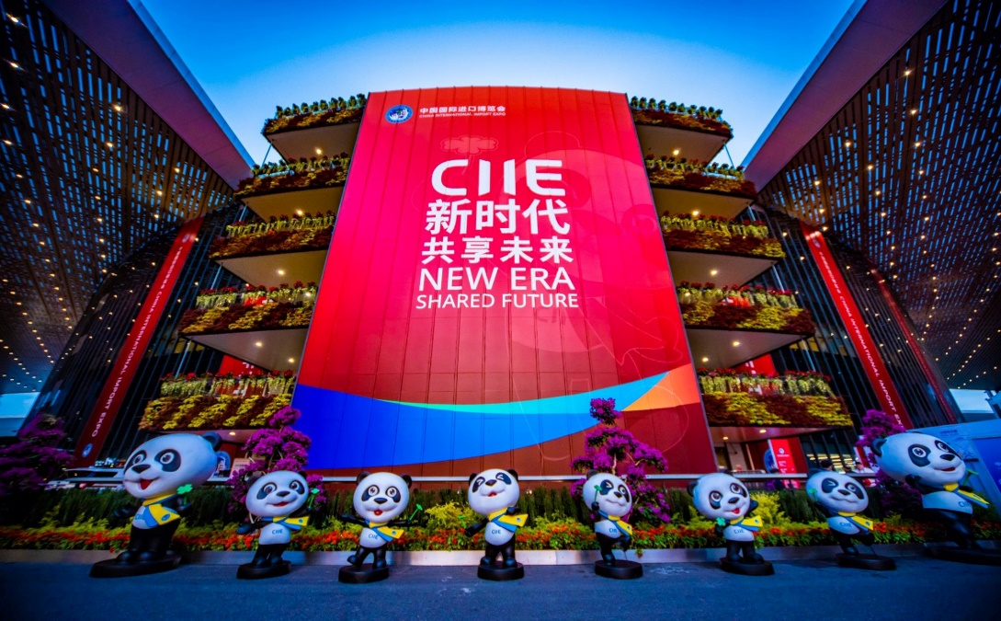
A façade at the NECC featuring this year’s theme along with the official CIIE mascot, Jinbao.
Philippine food exhibitors booked around US$390 million in export sales in the 2nd China International Import Expo (CIIE) held at the National Exhibition and Convention Center (NECC) in Shanghai, China, last 5-10 November 2019. This is more than three times the amount of what the Philippines registered from its 2018 participation which was at US$124 million.

Led by DTI Secretary Ramon M. Lopez, the 32 participating exhibitors that made up the 139-strong delegation for the 2019 CIIE was organized by the Department of Trade and Industry (DTI) through the Center for International Expositions and Missions (CITEM) in partnership with the Department of Agriculture (DA), the Export Marketing Bureau (EMB) and the Philippine Trade and Investment Centers (PTIC) in Shanghai, Beijing and Guangzhou.

“The big jump in sales since the last CIIE proves that China sees the Philippines as a significant source of agricultural products,” said DTI Secretary Ramon M. Lopez. “Suppliers should increase their production to better meet the demands of the Chinese market,” added Lopez given the improved performance of this year’s delegation.

To supplement the promotion of the Philippines’ well-received food exports, Chef Bea Nitard of the Via Mare Group held live cooking demos and food-sampling activities to help draw in even more tradeshow goers to the FoodPhilippines Pavilion. Chef Nitard developed dishes and desserts highlighting Filipino ingredients through different applications, adapting each dish to Asian and Chinese tastes. Through these activities, it was observed that Chinese consumers do not shy away from trying new flavors and cooking styles. This observation opens up new avenues and possibilities for Filipino food exporters and chefs to explore.

“Through this participation, we shall continue to improve the bilateral trade relations between the Philippines and China as we forge stronger bonds with China and the rest of the world,” said DTI Undersecretary Abdulgani Macatoman during the opening of the FoodPhilippines Pavilion.

Undersecretary Macatoman also noted the presence of halal foods featured by 19 of the 32 exhibitors as the Philippines’ response to the rapid growth of the health and wellness sector in the global market. “Through these efforts to further promote healthier consumer foods and beverages, the Philippines aims to solidify its place as a key player in this growing sector,” he adds.

This year’s Philippine delegation is comprised of the following exhibitors: 22 Propack Asia Corporation; AgriNurture, Inc.; Benevelle Corporation; B-G Fruits & Nuts Mfg. Corp.; Century Pacific Food, Inc.; Eng Seng Food Products; Excellent Quality Goods Supply Co.; Filifresh International Trading; Fisher Farms Incorporated; Fruits of Life, Inc.; GSL Premium Food Export Corp.; Jamla Corporation; Magic Melt Foods, Inc.; Magsasakang Progresibo Marketing Cooperative; Mancoco Food Processing Inc.; Monde M.Y. San Corporation; Monde Nissin Corporation; Pasciolco Agriventures; Pearl Foods International, Inc.; Phil. Morinda Citrifolia Inc.; Philippine Franchise Association; Pixcel Transglobal Foods Inc.; Primex Coco Products, Inc.; Roxas Sigma Agri Ventures, Inc.; S&W Fine Foods International, Limited; San Miguel Foods; See’s International Food Mfg. Corp.; SL Agrifood/Agritech Corporation; Team Asia Corporation; Trans Ocean Food Products, Inc.; Tropicana Food Products, Inc. and W.L. Foods.

The Philippine Pavilion received an estimated number of 6,000 buyers and visitors during the 6-day event. The best-selling Philippine products at the expo were fresh bananas, pineapples, mangoes and durian. These were followed by processed fruits & nuts and other coconut-based products.

With the positive reception and results from this year’s Philippine exhibitors, both the DTI and the DA are expecting a much bigger participation in the 2020 edition of CIIE.

###
Ref: Ryanorlie B. Abeledo
Tel: (+632) 831 2201 local 253
Email: rabeledo@citem.com.ph
Website: www.citem.gov.ph
Twitter: @CITEMPh
Facebook: @DTI.CITEM

