Photo Release

FoodPhilippines returns to the 2nd CIIE for a “New Era, Shared Future” with China

The 2nd China International Import Expo (CIIE) opened its doors to the public this week to welcome visitors to a bigger and better import expo with more than 3,000 foreign companies from 150 countries and regions. This year’s theme, “New Era, Shared Future,” reinforces China’s efforts to transition towards a more open economy to better accommodate exporters the world over.

The Philippine participation for the 2019 CIIE is organized by the Department of Trade and Industry’s Center for International Trade Expositions and Missions (DTI-CITEM) together with the Export Marketing Bureau (EMB), the Foreign Trade Service Corps (FTSC), the Philippine Trade and Investment Centers (PTICs) in China, PhilExport and the Department of Agriculture.

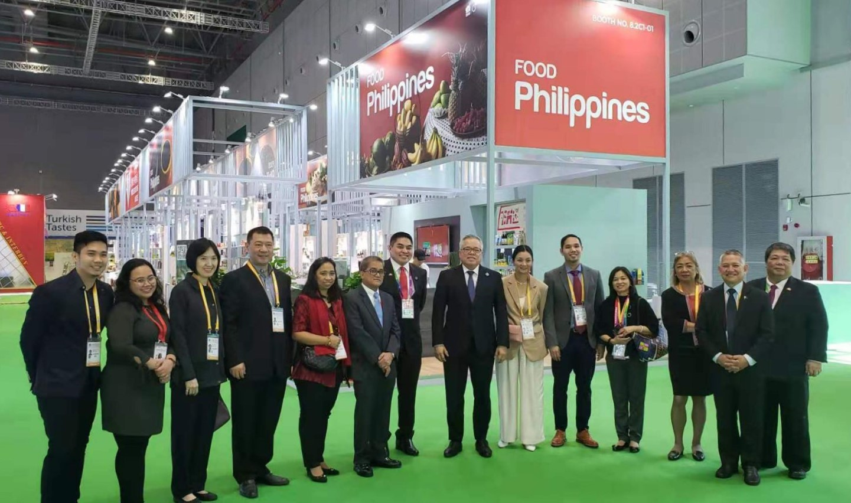
L-R: EMB Officer RD Velasco, Bureau of International Trade Relations Officer Michelle P. Pontillas, Ms. Lang Eng Kee of Tropicana Food Products Inc., Mr. Jimmy Tang of Team Asia Corporation, CITEM Project Manager Rowena Mendoza, Bureau of International Trade Relations Assistant Director Angelo Salvador M. Benedictos, DTI Undersecretary Abdulgani Macatoman, DTI Secretary Ramon Lopez, CITEM Executive Director Pauline-Suaco Juan, PTIC Shanghai Commercial Vice Consul Mario Tani, EMB Assistant Director Agnes Legaspi, PH Agricultural Counsellor Anna Abuejuela, PTIC Beijing Commercial Counsellor Glenn Peñaranda, PTIC Guangzhou Commercial Vice Consul John Paul Iñigo.
DTI Secretary Ramon M. Lopez, joined by DTI Undersecretary Abdulgani Macatoman and CITEM Executive Director Pauline Suaco-Juan, led the Philippines’ government representatives as they surveyed the Philippine pavilion prior to the event’s public opening.

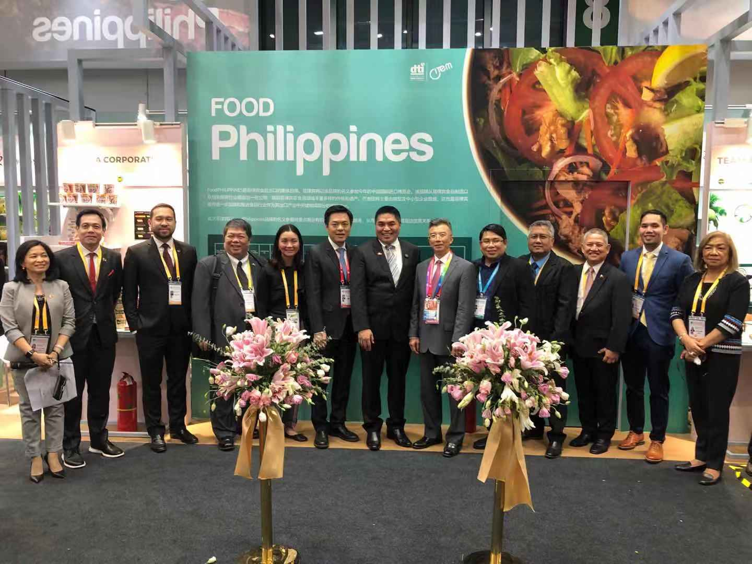
L-R: EMB Assistant Director Agnes Legaspi, Philippine Franchise Association Chairman Dr. Alan Escalona and President Richard Sanz, PTIC Guangzhou Commercial Vice Consul John Paul Iñigo, CITEM Executive Director Pauline Suaco-Juan, MOFCOM General Office Deputy Director General Jin Yuan, DTI Undersecretary Abdulgani Macatoman, MOFCOM Asia Affairs Director General Gang Peng, Consul Conrado Demdem from the Philippine Consulate General in Shanghai, Department of Agriculture Deputy Director Junibert De Sagun, PTIC Beijing Commercial Counsellor Glenn Peñaranda, PTIC Shanghai Commercial Vice Consul Mario Tani, PH Agricultural Counsellor Anna Abuejuela
Representatives of the Philippine delegation were joined by Ministry of Commerce (MOFCOM) Asia Affairs Director General Gang Peng and General Office Deputy Director General Jin Yuan for a group photo after DTI Undersecretary Abdulgani Macatoman formally opened the FoodPhilippines Pavilion.

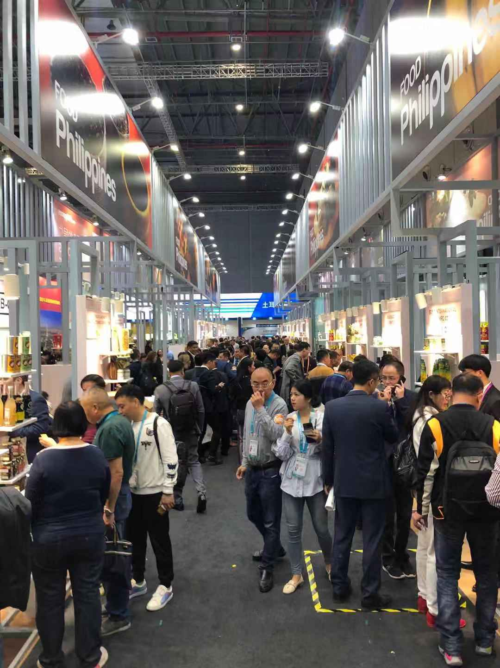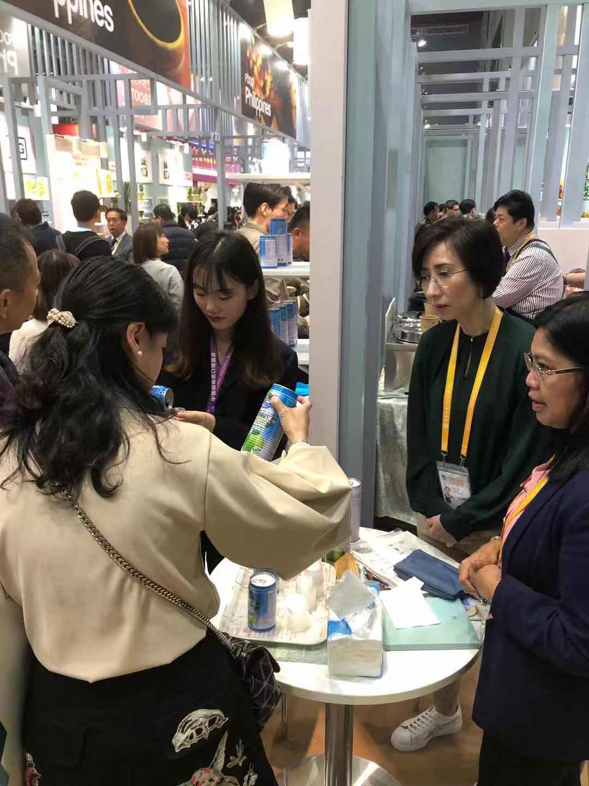
Crowds flock to the FoodPhilippines Pavilion as exhibitors showcase high-quality food and beverage products including various healthy and organic options.
Companies exhibiting under the FoodPhilippines banner feature a wide range of top-notch export products like fresh fruits, canned seafood, snack foods and various fruit-based products.

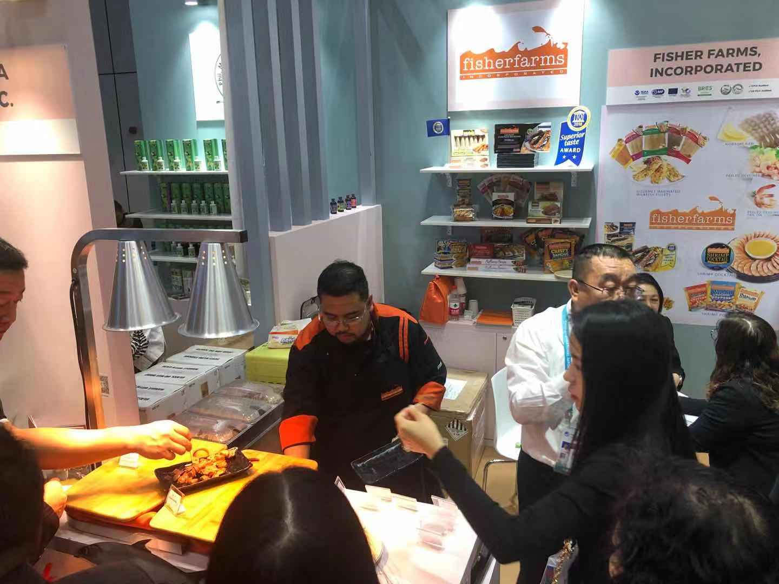
Food sampling activities at the FoodPhilippines Pavilion
Onsite food sampling activities will also be held throughout the show to give visitors a taste of the featured Philippine products at the trade show floor.

