Press Release: Business

Local MSMEs gear up for China’s premiere import expo as event countdown continues with less than 50 days to go
- The China International Import Expo (CIIE) is Chinese President Xi Jinping’s major initiative towards economic openness, globalization and international cooperation.
- Philippine micro, small and medium enterprises (MSMEs) will be returning to the 2nd CIIE to showcase the country’s top food products.

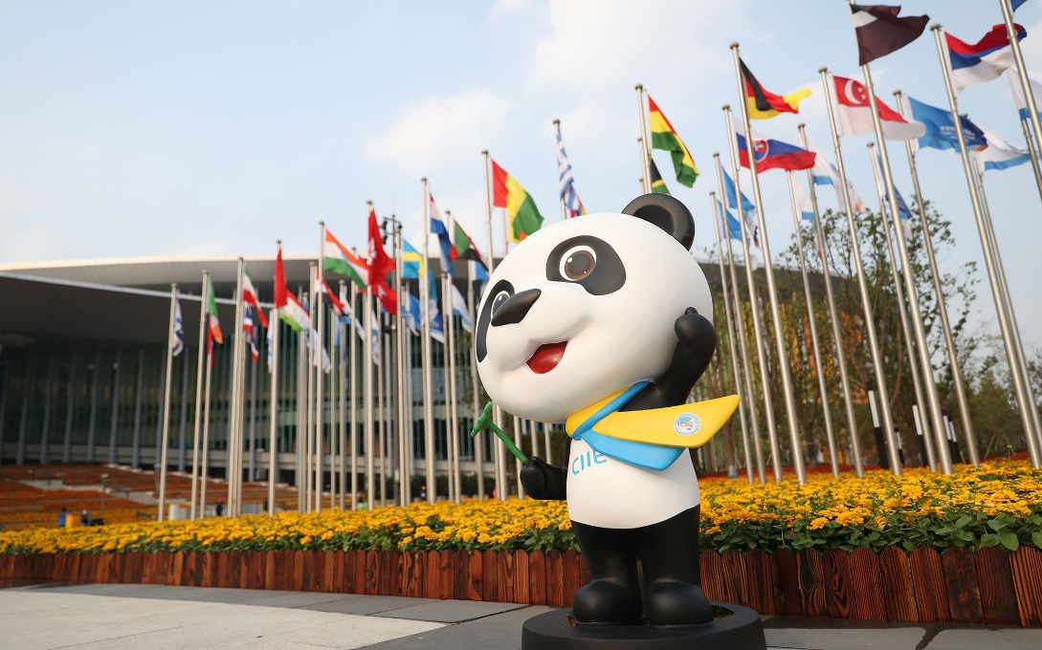
CIIE mascot, Jinbao the panda, representing friendship, good fortune and the modern Silk Roads of today.
With the 2nd edition of the China International Import Expo (CIIE) being less than two months away, organizers and exhibitors are now entering the home stretch as they begin final preparations for the upcoming event. CIIE 2019 will open its doors to around 3,000 companies from over 150 countries and regions at the National Exhibition and Convention Center (NECC) in Shanghai, China this 5-10 November 2019.

Currently one of the largest and fastest-developing economies in the world thanks to its large population base, China continues its initiatives for economic openness, globalization and international cooperation through this import-only expo. The enthusiastic response from participants for this year’s edition has already prompted organizers to open the registration for the 3rd CIIE slated for 2020.

This import expo provides an ideal platform for companies and exporters to promote their products, market their brands, sustain business relations and find new trade partners from the second largest economy in the world. According to a recent global economic forecast by Euromonitor, China’s projected economic growth for 2019 through 2021 puts it ahead of the USA in the global economy leaderboard, further augmenting the benefits of potential export deals with the country.

Improved import expo

New categories have been added to this year’s expo, opening up trade opportunities in the industries of autonomous driving technologies and elderly care services. The exhibition area itself has increased from 270,000 to 300,000 square meters to accommodate the number of guests, participants, Fortune 500 companies and events that are all expected to exceed those of last year’s expo.

Of the seven categories under CIIE’s business exhibition, the Philippines will be exhibiting as part of the Food and Agricultural Products sector. The participation, organized by the Department of Trade and Industry (DTI) through the Center for International Trade Expositions and Missions (CITEM), is now composed of more than 30 exhibitors set to showcase a wide range of top-notch products and services aimed at China’s fast-growing health and wellness market.

The participating companies from the Philippines’ food and beverage sectors will be exhibiting under the FoodPhilippines banner where they will showcase a wide variety of quality and innovative food products suited for China’s fast-growing health and wellness market.

Except for a few large-scale corporations, the Philippine delegation in the upcoming import expo will mostly be made up of companies from micro- to small-scale enterprises. This is in line with the Philippine government’s push to further strengthen and advance its micro, small and medium enterprises (MSMEs).

“CIIE serves as a perfect example of China’s efforts to further open its market to foreign trade, as well as a new trading platform that promotes the advancement of the overall global economy,” said DTI Undersecretary Abdulgani Macatoman. “It provides great opportunities for our MSMEs to grow their businesses beyond their local operations and capture more sectors of China’s developing market as the Philippines continues to strengthen its bilateral relations with China.”

DTI-CITEM, together with its partner agencies, will be focusing on a smaller MSME and business delegation as they continue to develop this year’s participants for export competitiveness in both the Chinese and global markets.

“We are inviting all trade buyers and guests alike to visit the FoodPhilippines area and discover the best food products that the Philippines has to offer and explore lucrative trade opportunities as our exhibitors deliver top-notch products and services from the Philippines’ food and agricultural industries,” added DTI-CITEM Executive Director Pauline Suaco-Juan.

This participation organized by DTI-CITEM in partnership with the Department of Agriculture (DA), the Export Marketing Bureau (EMB) and the Philippine Trade and Investment Centers (PTIC) in Shanghai, Beijing and Guangzhou.

Exporters from the food and agricultural sectors interested in joining this year’s CIIE may contact Peter Tapang, Project Officer, via email at pjtapang@citem.com.ph.

###
Ref: Ryanorlie B. Abeledo
Tel: (+632) 831 2201 local 253
Email: rabeledo@citem.com.ph
Website: www.citem.gov.ph
Twitter: @CITEMPh
Facebook: @DTI.CITEM

