Press Release: Business

PH to highlight organic food products in CIIE 2019
- DTI-CITEM will feature organic and specialty food companies in one of the world’s largest import-oriented expos.

Foods, beverages and ingredients made from coconuts are widely known for their various health benefits.
China is currently one of the fastest growing health and wellness (HW) markets in the world. Its demand for packaged HW foods and beverages has been on the rise since 2018 in response to the domestic market’s shift in consumer behavior towards a healthier, more natural and organic diet. To address this, the Philippines will promote a bevy of organic and specialty food products in the second edition of the China International Import Expo (CIIE) this 5-10 November 2019 at the National Exhibition and Convention Center (NECC) in Shanghai, China.

This participation is organized by the Center for International Trade Expositions and Missions (CITEM), the export promotion arm of the Department of Trade and Industry (DTI), in partnership with the Department of Agriculture (DA), the Export Marketing Bureau (EMB) and the Philippine Trade and Investment Centers (PTIC) in Shanghai, Beijing and Guangzhou. Fifty exhibitors from the Philippines’ food and beverage sectors are being eyed to be featured in the Food and Agricultural Hall of the import-exclusive expo. These exhibitors will showcase a wide range of products and services including coconut-based products, fresh and processed fruits and vegetables, fruit-based products, frozen and canned meats and seafood, snack foods, beverages and food and agricultural services.

According to a recent study by Nikkei Asian Review, China is poised to surpass the USA and take its place as the world’s largest consumer market this year. This projected economic growth and the increasing purchasing power of China’s middle- and upper-classes makes the import expo the perfect trading platform for exporters. The Philippines can tap into this lucrative consumer market by showcasing a variety of world-class exports from the country’s rich and culturally infused food industries to cater to the current health trends observed in the Chinese market.

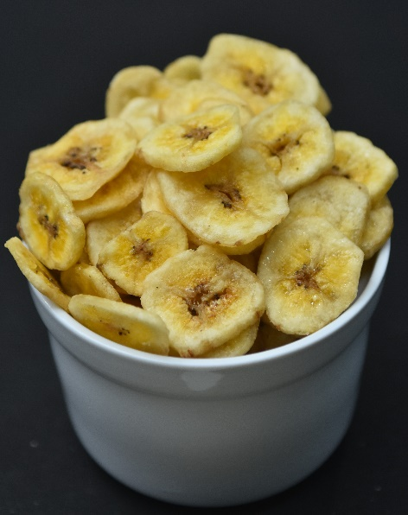
Bigger and Better CIIE

With CIIE being just on its 2nd edition this year, majority of the Philippine companies confirmed to exhibit at the expo will be joining for the first time. Some of these include Century Pacific Food, Fisherfarms, Monde Nissin, Fruits of Life and San Miguel Pure Foods, to name a few. They are accompanied by six returning exhibitors, namely, W.L. Food Products, Excellent Quality Goods Supply, Phil. Morinda Citrifolia, Philippine Franchise Association, Team Asia Corporation and Brandexports Philippines.

“The Philippine delegation for this year’s CIIE aims to generate a sales target of US$5 million as they promote world-class Philippine food products to potential Chinese and international clients. This move will strengthen and improve the country’s trade relations across Asia and the rest of the world,” said DTI-CITEM Executive Director Pauline Suaco-Juan.
Cardava banana chips will be one of the top-featured products at the expo

Topping the list of featured products are coconut-based beverages and ingredients with 10 exhibitors carrying the commodity. This is in response to the current shift in dietary preferences given the various health benefits associated with coconut water and other related ingredients like coconut oil, coconut milk and coconut flour. Philippine bananas will also make their mark at the expo with eight exhibitors bringing a variety of fresh and banana-based products. These are bound to drum up their fair share of sales since China has become the biggest importer of Philippine bananas since 2018. Both product lines will be showcased along other healthy food offerings like fruit preserves, mango flour, dried fruits and fruit juices.

“We are encouraging our exhibitors to take this opportunity to further position the Philippines in the global market as a premier source of healthy and organic food products by promoting the world-class quality of our products and services and our export capabilities at the upcoming China International Import Expo,” adds DTI Undersecretary Abdulgani Macatoman.

Exporters from the food and agricultural sectors interested in joining this year’s CIIE may contact Ms Janine Briones, Project Officer, via email at jbriones@citem.com.ph.

###
Ref: Ryanorlie B. Abeledo
Tel: (+632) 831 2201 local 253
Email: rabeledo@citem.com.ph
Website: www.citem.gov.ph
Twitter: @CITEMPh
Facebook: @DTI.CITEM

