Award-winning PH chocolate brands to be featured in the Netherlands’ top chocolate and cacao show

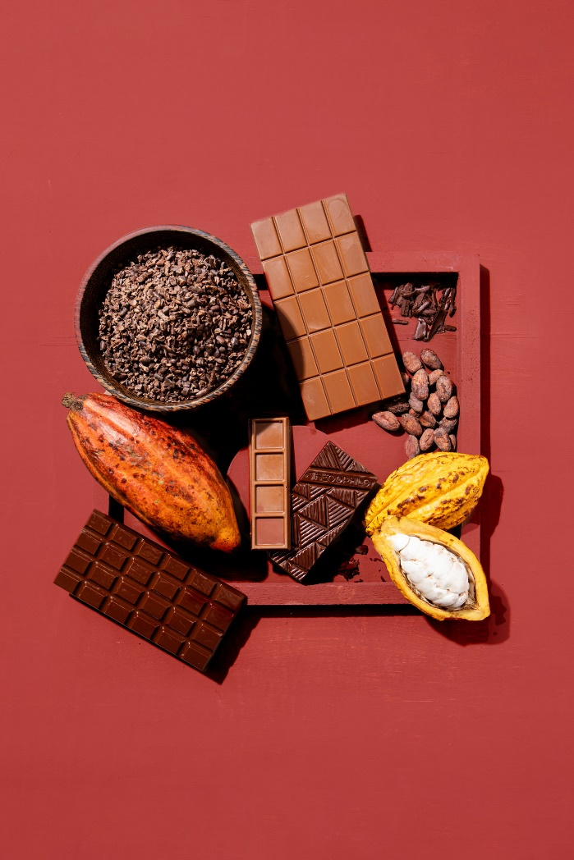
The Philippines gears up its award-winning chocolate makers and cacao producers for a country exhibit in the Cocoa Trade Show & Chocolate Festival, also known as CHOCOA, at the Beurs Van Berlage, Amsterdam, the Netherlands, on 19-23 February 2020.
The FoodPhilippines delegation is set to showcase eight Philippine producers and manufacturers of chocolates and other value-added cacao products including local brands that have earned global recognition. It will be led by the Department of the Trade and Industry, through the Center for International Trade Expositions and Missions (DTI-CITEM), in partnership with the Philippine Trade and Investment Center (PTIC) in Brussels, Belgium, and the Rural Agro-Industrial Partnership for Inclusive Development (RAPID) Growth Project, funded by the International Fund for Agricultural Development (IFAD).
“The Philippine chocolate and value-added cacao products have been making waves in the international market for its distinct flavor profile and high-quality beans,” said CITEM Executive Director Pauline Suaco-Juan. “We want to make a statement that the Philippines is ready to take on the global cacao demand by showcasing some of our top brands in Netherlands, the world’s leading importer of cacao beans.”
Visitors in Chocoa will get a full taste of Philippine chocolates and value-added cacao products from bean to bar.

Below are the five award-winning Philippine firms with their brands to be showcased in CHOCOA:

Malagos Agri-Ventures Corporation

Malagos Chocolates is one of the frontline brands of the Philippines in the international market. Launched in 2012, the brand has made a name with its line of single-origin 100%, 85%, 72% and 65% dark and drinking chocolates, earning multiple awards from the Academy of Chocolates, International Chocolate Awards and Great Taste, among others. Now, they offer chocolate beer and chocolate variants with truffles and tropical fruits. The Puentespina Farm, where its beans are cultivated, earned its heirloom status from the Heirloom Cacao Preservation Fund in 2019 for growing one of only 16 Heirloom Cacaos in the world. In 2017, Malagos Chocolates’ cacao bean made it to the list of the “Best 50 Beans in The World” under the Cocoa Excellence Programme.

Auro Chocolates/Filipinas Oro de Cacao

Another multi-awarded brand under the FoodPhilippines roster is Auro Chocolates. The company takes pride for its bean-to-bar process since they have cacao beans that are fully traceable in planting communities in the Philippines. Their chocolates are made with 100% premium cacao butter and premium ingredients with no extenders and processed in a state-of-the-art facility where it is properly segregated and classified to optimize the flavors of Philippine cacao. Its commitment to quality has earned it 23 international awards including the Top 20 Best Cacao Beans Award—a first for the Philippines—in the International Cocoa Awards (ICA) in Salon du Chocolat Paris with their partner farmer, Jose Saguban. Auro shines in the global market as it offers chocolate varieties from their Classic, Heritage, Reserve and Tropical collections living up to its name which is taken from the chemical symbol of gold and the Spanish word “Oro.”

Theo and Philo Chocolate Factory, Inc.

Theo & Philo takes pride in its use of high-quality local ingredients from the cacao beans of Davao and the sugar of Bacolod which are molded into perfection. The company sets itself apart with its fearless use of tropical fruits and ingredients, and takes inspiration from local cuisines to create flavors that are undeniably Filipino. Among its treats that garnered recognition from the London Academy of Chocolates and the International Chocolate Awards are their 65% Dark Chocolate with Labuyo, Milk Chocolate with Pili Nut & Pinipig, 65% Dark Chocolate with Calamansi, Milk Chocolate Turon, 65% Dark Chocolate with Black Sesame and Milk Chocolate Adobo.

MS3 Agri-Ventures Corp.

MS3 Agri-Ventures Corp. is a newly emerging chocolate brand in the Philippines recognized for its Dark Chocolates, Cashew and Coffee Granules and 100% Dark Chocolate Cacao Tablet (2019 Academy of Chocolates), Unsweetened Chocolates (2018 Academy of Chocolates) and 75% Dark Chocolate with Coco Sugar (Top 10 Finalist in the 2019 SIAL Food Innovation Awards in Middle East). Touted as the “Philippines’ Best Cacao Tablet Producer” in the Asia HALAL Brands Awards in 2017, the company is made up of farmers unified with a cause to create thriving cacao communities from the value-added products that they produce and offer to their patrons.

Kablon Farm Food Corporation

Kablon Farms is a chocolate brand that adheres to sustainable methods of farming and is known for producing spicy dark chocolates made available in 60% and 70% variants. The cacao flavor profile of Kablon Farms is enhanced by the tropical vegetation that grows alongside it, including coconut, mangosteen, guava, jackfruit, durian and passionfruit. Its 70% Dark Chocolate won in the Academy of Chocolate Awards and was a Double Gold Star Winner in Great Taste in 2017.

Emerging Cacao and Chocolate Producers

The FoodPhilippines Pavilion shall also sample products from Tigre y Oliva Chocolates (Tiger Craft Food and Beverage Co.), another emerging chocolate brand in the country. Likewise, Biao Agrarian Reform Beneficiaries Cooperative and Kennemer Foods International, Inc. are also looking to showcase their cacao beans and other value-added products.

###
Ref. Ryanorlie Abeledo
Tel: 831-2201 local 253
Email: rabeledo@citem.com.ph
Twitter: @CITEMPh
Facebook: @DTI.CITEM

