PH set to join the Netherlands’ top chocolate trade fair for the first time as it strengthens cacao export drive in EU

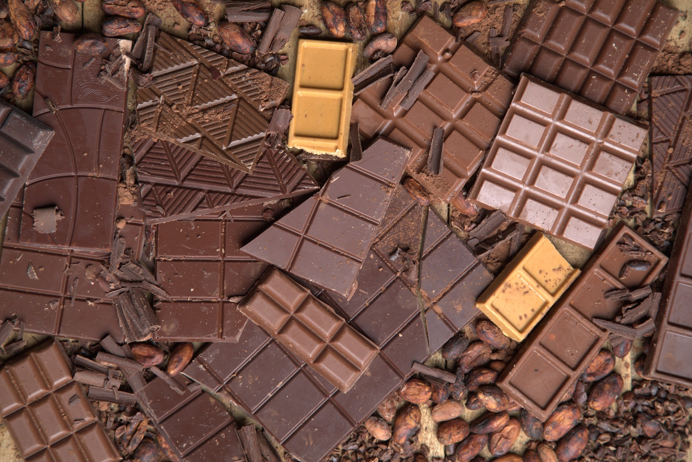
The Philippines will feature chocolate products in the Netherlands.

The Philippines is set to showcase its globally competitive chocolates and cacao-made products in a series of activities in the Cocoa Trade Show & Chocolate Festival, popularly known as CHOCOA, at the Beurs Van Berlage, Amsterdam, Netherlands on 19-23 February 2020.

CHOCOA is a five-day event wherein 10 activities take place with the overlapping goal to make the cocoa and chocolate industry better in terms of quality and more sustainable in terms of fair trade.

Seven food producers and manufacturers from Davao del Sur and South Cotabato will be representing the Philippines in the country’s first participation in CHOCOA. The delegation will be led by the Department of Trade and Industry, through the Center of International Trade Expositions and Missions (DTI-CITEM), in partnership with the Rural Agro-enterprise Partnership for Inclusive Development and Growth (RAPID Growth) Project and the Philippine Trade and Investment Center (PTIC) in Brussels.

Forming the Philippine delegation are Malagos Agri-ventures Corporation, Kennemer Foods International Inc., MS3 Agri-ventures Corporation, Theo and Philo Chocolate Factory, Inc., Tiger Craft Food and Beverage Company Inc., Kablon Farms and Biao Agrarian Reform Beneficiaries Cooperative.

“We are starting strong this year in our export drive on cacao and chocolate with the country’s first participation at CHOCOA in Netherlands, known as the leading chocolate import event in Europe,” said Abdulgani Macatoman, DTI Undersecretary for Trade and Promotions Group. “This participation should allow our cacao producers to generate new market leads and further broaden its reach in countries within the European Union (EU).”

“We expect that our specialty chocolates will be particularly popular since there is an increasing demand for high-quality chocolate from Dutch consumers and they are willing to shell out extra for better tasting and more sustainably sourced products,” he added.

The Netherlands is the world’s main importer of cocoa beans, reaching 991,000 tonnes in 2017, valued at € 2.2 billion, based on a report by the Centre for the Promotion of Imports which is based in the Netherlands. It is also home to the world’s second-largest cocoa grinding industry, after only the Ivory Coast, consuming an estimate of 565,000 tonnes of cocoa beans between 2016 and 2017.

Macatoman said the Philippines will be joining all the activities in the event, which includes the Chocolate Trade Fair, which will be attended by around 1,500 business-to-business visitors and stakeholders from the entire cocoa supply chain including cocoa producers, chocolate manufacturers, trade and industry, governments, NGO’s, financial and logistic services suppliers and consumers.

Another activity is the Chocolate Festival set wherein 9,000 visitors are expected to come to taste and buy chocolate. Other activities will include the European Markets Academy, Chocolate Master Classes and Conference that takes place during the five-day event.

The Philippines as a globally competitive cacao producer

The Philippines produced cacao from as far back as the 17th century. Situated between 10 to 20 degrees north and south of the equator or known as the “Cocoa Belt,” the Philippines has a suitable geographical and climate conditions to provide support for global production.
All of the three varieties of cacao beans are present and grown in the country. Majority of cocoa beans produced are mid-value Trinitario beans. Criollo beans, which are mainly from older trees, have lower yield but are still being produced, while high-value varieties of Forastero beans are beginning to be planted in some farms.
“Cacao is currently one of the country’s top export products since the Philippines is among the few countries in Asia that are seen to have a competitive advantage on cacao production given its strategic location and climatic condition,” said CITEM Executive Director Pauline Suaco-Juan.

By 2020, the country eyes to produce 100,000 metric tons (MT) of fermented beans for the export and domestic markets, based on the 2016-2020 Philippine Cacao Roadmap released by the Department of Agriculture.

In targeting the EU market, Suaco-Juan said the Philippines also benefits from the stringent EU limits set on the heavy metal, given the cacaos from Davao and other places in Mindanao have low cadmium levels well within the acceptable values.

Mindanao, the southernmost group of islands in the Philippines, accounts for 90 percent of the Philippine cacao production, with 80 percent coming from the Davao Region alone. Majority of Mindanao cacao producers are small farm holdings. Davao Region has more than 20,000 hectares of cacao farms with Davao City occupying the largest area of around 6,060 hectares.
The tropical, earthy, nutty and sweet flavor of Philippine cacao is also known globally since the country is home to flavorful tropical cultivars that grows within its proximity. Its fruity taste is influenced by the presence of fruit trees such as calamansi, durian and guava. Beans from cacao farms intercropped with fruits and vegetables such as pomelo, bananas, tomatoes, lettuce and green beans can contribute to an earthy, tropical flavor. Areas that grow lots of mangoes can cause cacao varieties that are naturally sour to taste less acidic.
###
Ref. Ryanorlie Abeledo
Tel: 831-2201 local 253
Email: rabeledo@citem.com.ph
Twitter: @CITEMPh
Facebook: @DTI.CITEM

